User Manual for Network QR Code Access Control Machine
TCP-701

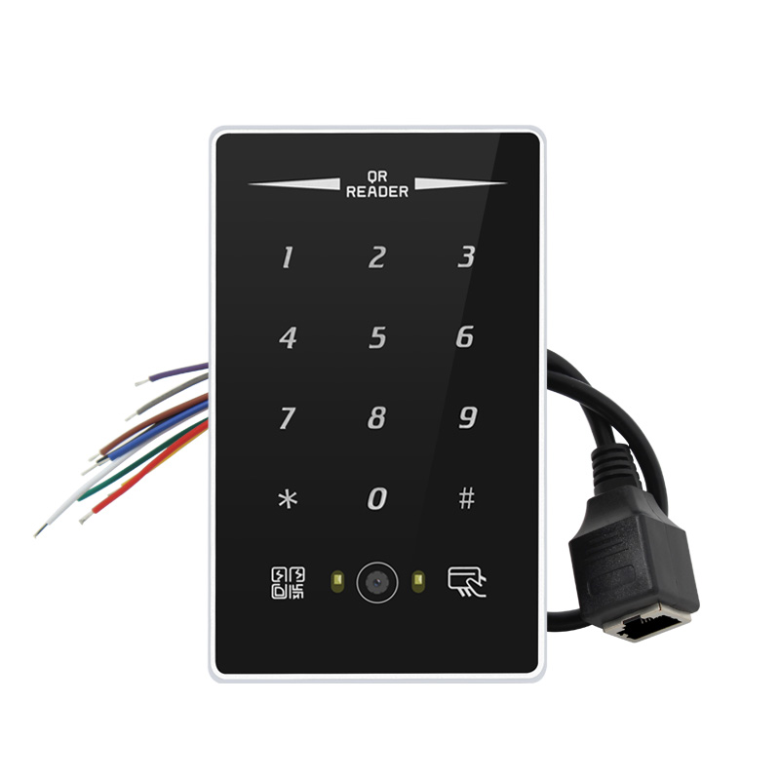

Product Overview
This network access control machine integrates a high-performance serial port to Ethernet core chip, supports multiple network working modes and flexible configuration methods, and can achieve networked access, remote data transmission, offline and remote management of access control equipment. It is suitable for the network communication requirements of various access control application scenarios and features stability, ease of use and strong scalability.

Basic Parameters

Electrical parameters
- Working voltage：9-24V (DC)
- Operating current: 40mA
- Operating temperature and humidity: -40 to +85°C, 5% to 95% RH (no condensation)
- Storage temperature and humidity: -40 to +105°C, 5% to 95% RH (no condensation)

plant parameter
- Operating frequency: 13.56 MHz
- Supported card types: IC, NFC
- Scan types: barcode, QR Code, Data Matrix, PDF417, Hanxin Code, etc.
- Reading angle: 360° rotation, elevation ±55°, tilt ±55°
- Scanning angles: 72° (horizontal), 54° (vertical), 84° (diagonal)
- Protocol type: IOS14443A
- Induction distance: 5-8 cm
- Scan distance: 30 cm
- Interface type: RJ45
- Product dimensions: 120X72X18mm
- Material composition: Zinc alloy + high-temperature tempered glass
- Keyboard type: Multi-touch
- Water resistance: IP65
- Working modes: TCP Server, TCP Client, UDP Server, UDP Client, HTTP, MQTT, Modbus Gateway
- User storage: 20,000
- Offline log: 60000

Device Features
- Time-limited and frequency-based features
- Remote device update
- Remote permission modification
- Dynamic password settings
- Open Door Inquiry
- door magnet state feedback
- Remote door opening
- External card reader
- External door opening button
- Visitor feature

Sequence Description
Sequence number | Sequence Description | function declaration
1: Red | VCC | DC 9-24V wide voltage positive terminal
2: Black | GND | Negative terminal of power supply
3: Green | OPEN | External door opening button, which opens the door through short-circuit contact with GND
4: White | MC | door magnet feedback
5: Blue | D0 | External card reader Wiegand 26 D0 data cable
6: Yellow | D1 | External card reader Wiegand 26 D1 data cable
7: Gray | NC | Relay normally closed
8: Brown | COM | common terminal of relay
9: Purple | NO | Relay normally open

III. Functional Features
supports seamless switching between multiple operating modes (TCP Server, TCP Client, UDP Server, UDP Client).
supports web page settings, configuration tool settings, and AT command parameter configurations.
supports multiple Socket connections;
supports DHCP functionality;
Customize the DNS server address 
supports multiple Modbus gateways, including simple protocol conversion, multi-host mode, storage-based gateways, and configurable gateways.
supports fast access to Alibaba Cloud, Baidu Cloud, OneNET, Huawei Cloud, and version 3.1 standard MQTT servers;
supports HTTP protocols (GET/POST requests);
supports timeout-based restart with customizable restart intervals.
supports heartbeat packets and registration packet functions;
supports access to both external and local networks.
supports online upgrade.

IV. Network Parameters
- Working modes: TCP Server, TCP Client, UDP Server, UDP Client, HTTP Client, MQTT Client (default TCP Server)
- Socket connection: Supports 6 client connections (TCP server mode)
- Network protocols: IP, TCP/UDP, IPv4
- IP acquisition method: DHCP, static IP (default static IP)
- Domain resolution: Supported. You can customize the DNS server address.
- Default network configuration
IP address: 192.168.3.7 Gateway: 192.168.3.1
Local port: 8887 Target IP: 192.168.3.3 Subnet mask: 255.255.255.0 Target port: 8888

